Unit 5 Why do you like pandas?

Period 1（Section A 1a-2c）

教学目标
1. 知识目标：
（1）掌握单词：panda，zoo，tiger，elephant，koala，lion，giraffe，animal，cute，lazy，smart，beautiful。
（2）掌握句型：—Let’s see...
—Why do you want to see...?
—Because they’re/it’s...
（3）运用英语谈论、描述动物，表达自己对动物的喜爱。
2. 能力目标：
（1）学会运用let’s祈使句、why引导的特殊疑问句及because引导的原因状语从句。
（2）用英语谈论、描述动物，会熟练运用形容词描述性质、品质，表达自己对动物的喜爱。
3. 情感目标：
让学生认识动物，培养学生爱护动物、热爱大自然的意识。
重点难点
1. 重点：
动物的名称和描述动物特点的形容词；why引导的特殊疑问句及其简要回答。
2. 难点：
学会运用描述性形容词对动物进行描述；用why提问原因，用because表达理由。
教学准备
1. 准备本课时有关动物的图片。
2. 多媒体课件，1b的音频文件。
教学过程
Step 1 Warming up & Leading in
T：Good morning，boys and girls! Look at the screen and listen. Let’s enjoy the song Old MacDonald Had a Farm. How many kinds of animals are there on MacDonald’s farm?
Ss：Seven.
T：Which animals have the“moo”sound?
Ss：Cows.
T：Do you like animals?
Ss：Yes!
T：So do I. Can you say the names of some animals?
Ss：Yes. Dog，cat，lion，fish，tiger...
T：You are all very clever. This lesson，let’s see more animals in the zoo.
Step 2 Presentation
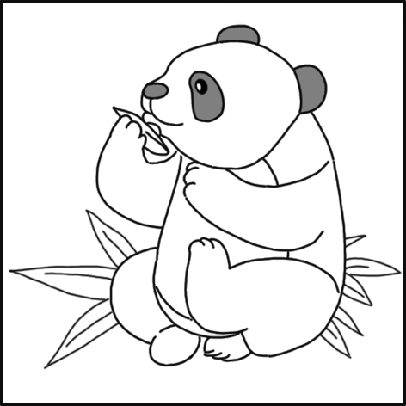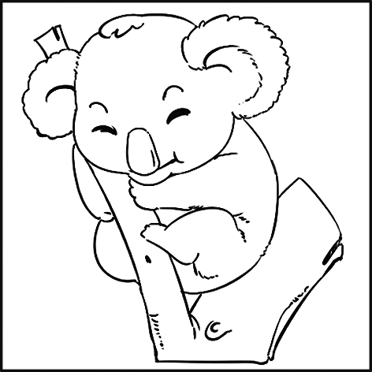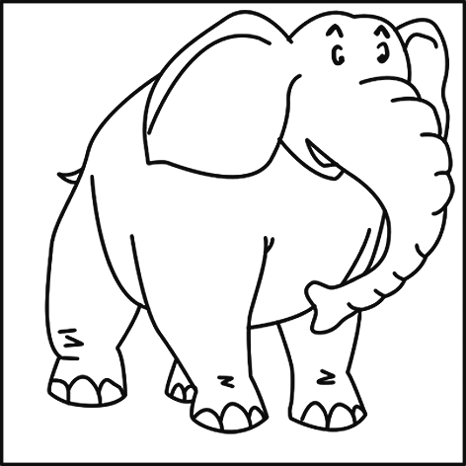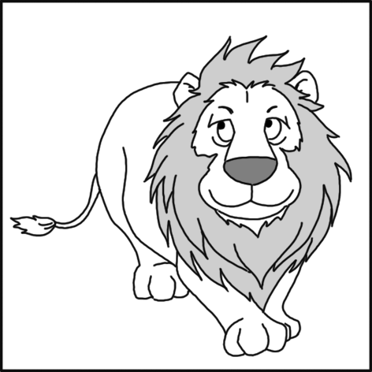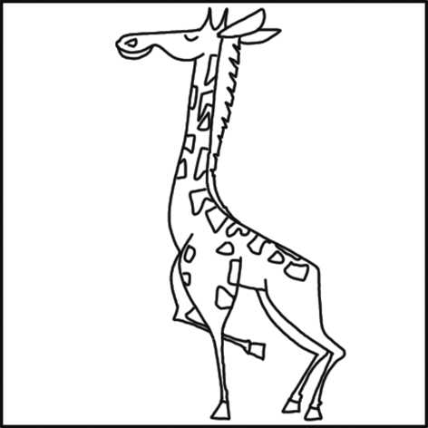
T：Look at the pictures. They are animals.（板书新单词animal）What animal is it in picture 1?
Ss：It’s a panda.
T：Do you like pandas?
S1：Yes，I do.
T：Why do you like pandas?
S1：Because they are beautiful.
T：Yes，they are beautiful and they are cute.
...
（New words：animal，panda，zoo，tiger，elephant，koala，lion，giraffe，cute，lazy，smart，beautiful）
Step 3 Practice
1. Guessing game.
Ask one student to imitate some animals，and other students guess what animals they are.
2. Look at the words in 1a. Match them with the animals in the picture.
Check the answers.
Answers：1. a 2. f 3. c 4. e 5. d 6. b
3. Match the animals with the Chinese meaning. Then describe the animals.
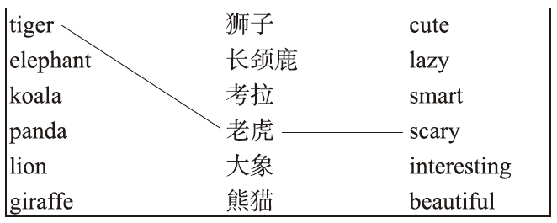
Tigers are scary. Elephants are

4. Talk about the animals in groups.
Step 4 Listening
1. Listen and check（√）the animals you hear in 1a.
2. Check the answers.
Answers：3. koala√ 4. panda√ 6. giraffe√
3. Listen again. What do they think of these animals? Write down the description word next to the animal.
Answers：koala：interesting panda：cute giraffe：beautiful
4. Describe the animals like that in Step 3.
5. Listen and repeat.
Step 5 Pair work
Your class will go to a zoo this Sunday. Decide what animal you want to see first and why.
1. Practice the conversation in 1c with your partner. Then make conversations about the other animals in 1a. Use the words in the box.
For example：
A：Let’s see the pandas first.
B：Why do you want to see them?
A：Because they’re very cute.
2. Practice in pairs.（Ask pairs of students to present their dialogues to the class.）
3. Now look at 1c. Translate the sentences into Chinese.
Let’s see the lions. 咱们看狮子吧。
Why do you want to see them? 你为什么想看它们？
Because they’re interesting. 因为它们有趣。
Step 6 Survey
Work in groups of four. Make a survey：What animals do you like? And why?
Name | Animals he/she likes | Why
Lucy | pandas | beautiful and cute
 | koalas | cute
1. Fill in the chart.
2. Report like this：Lucy likes pandas because they are beautiful and cute. She also likes koalas because they are cute...
Step 7 Group work
Talk about the language points in groups.
1. let’s为let us的缩写，但let’s通常用来提出建议，包括说话者和听话者；let us通常表示请求听话者允许说话者完成某一动作。
咱们（一起）去购物吧！Let’s go shopping!
李老师，让我们回家吧。Let us go home，Miss Li.
2. why是疑问副词，意为“为什么”，用来询问原因；英语中用why提出问题，用because回答。
“你为什么想看熊猫？”—Why do you want to see pandas?
“因为它们很可爱。”—Because they’re very cute.
3.“the+可数名词单数或可数名词复数”都可表示一类事物，在上下文中必须做到主谓一致、前后一致。
—Let’s see the panda.
—Why do you want to see it?
—Because it’s cute.
—Let’s see the pandas.
—Why do you want to see them?
—Because they’re cute.
Step 8 Summary
In this lesson，we have learned：
1. New words：panda，zoo，tiger，elephant，koala，lion，giraffe，animal，cute，lazy，smart，beautiful
2. Sentence structures：
—Let’s see...
—Why do you want to see...?
—Because they’re/it’s...

Step 9 Homework
1. Read and remember the new words of this lesson.
2. Make a survey. Ask your friends what animals they like and why.
Your friends | Animals he/she likes | Why
Li Wei | tigers | beautiful
板书设计
UNIT 5 Why do you like pandas?
Period 1（Section A 1a-2c）
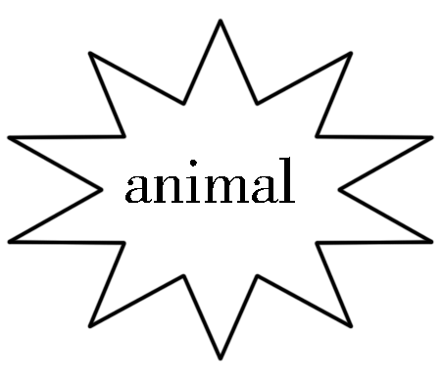Welcome to the zoo  panda cute  tiger lazy  koala smart  elephant beautiful  lion giraffe | Let’s see...  Why do you want to see...?  Because they’re/it’s...
教学反思

